[Your Company Name Here]

COVID-19

Cleaning and Disinfection

Safe Work Method Statement

METHOD STATEMENT
ADDITIONAL PRECAUTIONS AND SAFETY MEASURES IN EVENT OF CLEANING REQUIRED FOR SUSPECTED AND CONFIRMED COVID 19
Purpose
The following method statement is to support all existing method statements in the safe systems of work to contain and remove the effects of COVID-19.
Operation Information (To Be Completed)

Name of Operation:

Address of Operation:

Specific Activity Location:

Name and Address of Nearest Medical Center:

Activity Supervisor Name and Contact Information:

Date and Time of Proposed Activity Start:

Date and Time of Proposed Activity Completion:

Waste Disposal Organization Name and Address:

Required Equipment and PPE
PPE – over suit or apron, overshoes, gloves (consistent with SDS recommendations, surgical face mask, eye protection (goggles or face shield).
Anti-viral disinfectant (SDS REVIEW REQUIRED), disposable cloths and mops.
Buckets to capture disinfection media
Clinical waste bags (Yellow – Denotes “Clinical / Highly Infectious / Hazardous)
Clinical waste box
Means of establishing robust exclusion zones (including signage)
Access to water supply
Specific PPE to be Utilized During Activity

Over-Suit or Apron Brand and Model Name / #:

Overshoes Brand and Model Name / #:

Glove Rating, Brand, and Model Name / #:

Surgical Face Mask Brand and Model Name / #:

Goggles or Face Shield Brand and Model Name / #:

Manufacturer of Clinical Waste Bags (Yellow):

Manufacturer of Clinical Waste Box:

Application
The following safety and control, together with the procedure is to be read in support of all appropriate existing method statements and risk assessments. The purpose of the additional precautions is to increase the level of protection and add to the existing safe systems of working for operatives cleaning in environments with suspected or confirmed virus outbreaks.

Any employee who has either a severe respiratory disorder (COPD) or either an Immunosuppressed system and/or deliberately induced immunosuppressed system to prevent the body from rejecting an organ transplant CANNOT undertake this task.

Safety and Control
- RPE (Respiratory Protection Equipment) facemasks to be tested for seal prior to starting work and entry to contaminated area.
- If any damage to RPE occurs the full post cleaning procedure is to be followed immediately.
- If RPE becomes wet, the full post cleaning procedure is to be followed immediately
Cleaning to be carried out in shifts no longer than 3 hours, at which point the full post cleaning procedure is to be followed and new PPE to be worn.
Procedure
Prior to carrying out normal method statement
- Prior to arrival ensure all PPE and RPE is readily available.
- Check PPE and RPE is in working order.
- Carry out hand hygiene – wash and dry or sanitize hands.
- Put on PPE prior to entering the area where a suspected outbreak has been reported
- Check the face mask is sealed by exhaling and inhaling which forms a seal around the skin.
- Put the clinical waste bags in an easily accessible location in preparation for completion of tasks.
- Use disposable cloths or paper roll and disposable mop heads. Please refer to the risk assessment and method statement for the task being carried out.
After carrying out normal method statement
- Put all disposable products used and RPE/PPE into clinical waste bag secure shut (swan necktie) top of bag, then double bag again secured shut (swan neck tie) top of bag.
- Ensure double bagged to prevent contamination through torn bags.
- Seal and tag the bags/boxes and remove to a designated area for disposal in a clinical waste box.
- Wash and dry hands or sanitize thoroughly after completing the task.

Appendix A – Cleaning and Disinfection Process

Though it is understood that [Your company name here] does not operate in a “Healthcare Setting” as defined by regulatory bodies, the processes in which these areas are cleaned can be utilized to clean and disinfect our operations. This high level of planning will ensure that surfaces potentially containig infectious matter are cleaned and disinfected, while providing lower levels of risk during the operation (activity work flow is properly managed). The terminology and locations detailed within these documents (i.e.beds, blinds, etc.) may not be applicable to the specific operation being cleaning and disinfected, but serve as a guideline to the detailed cleaning and disinfecting approach.

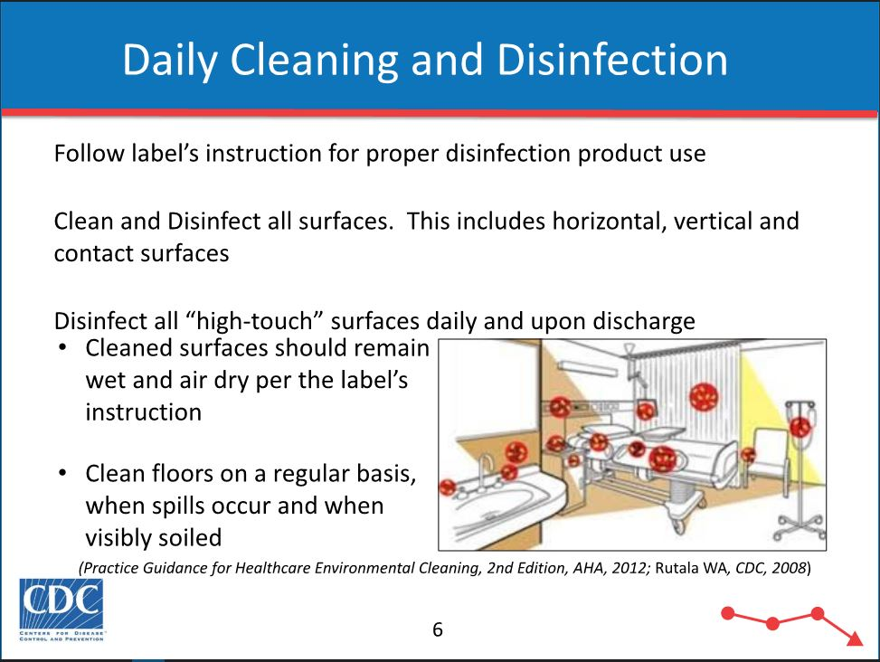

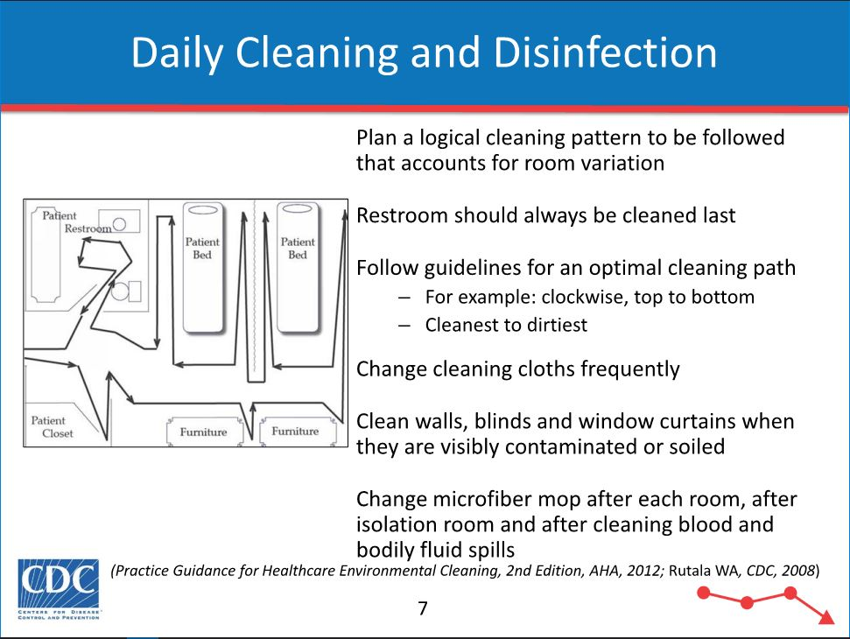

Appendix B – Clinical Waste Bag Examples

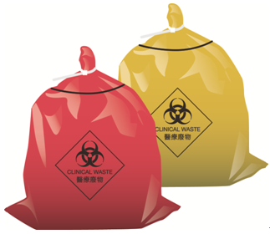

Appendix C – “Swan Neck” Method of Sealing Clinical Waste Bags

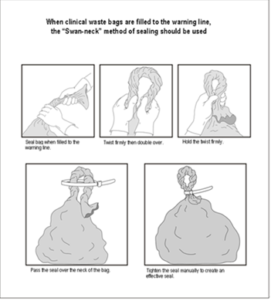

Appendix D – Respiratory Fit Testing

The "fit" or integrity of the facepiece to face seal of a respirator affects its performance. A secure fit is important with positivepressure equipment and is essential to the safe functioning of negativepressure equipment, such as air purifying respirators. Most facepieces fit only a certain percentage of the population; thus, each facepiece must be tested on the potential wearer in order to ensure a tight seal.

Recall that facial features such as scars, hollow temples, very prominent cheekbones, deep skin creases, dentures or missing teeth, and the chewing of gum and tobacco may interfere with the respiratortoface seal. A respirator shall not be worn when such conditions prevent a good seal. A worker's diligence in observing these factors shall be evaluated by periodic checks.

Two types of fit tests can be performed. The first is a qualitative fit test, which exposes the wearer to irritants (stannic chloride) or substances that have distinctive odors or tastes (banana oil or saccharin mist). If the facepiece fit is good, the wearer should experience no reactions or sensations related to the substance used.

The second type of test is the quantitative fit test, which is much more complicated and designed to produce a numerical value or fit factor indicating the degree of fit. The wearer is placed I an enclosure containing a known concentration of a contaminant. A sample is taken from inside the facepiece and the concentration of the contaminant is determined. The airborne concentration is divided by the concentration inside the facepiece to determine the fit factor.

For a qualitative respirator fit testing protocol, see Appendix D of the OSHA lead standard (29 CFR Part 1910.1025). For quantitative fit testing, see the NIOSH publication A Guide to Industrial Respiratory Protection. For specific quantitative testing protocols, literature supplied by manufacturers of quantitative fit test equipment should be consulted.

Note that certain OSHA standards require quantitative fit testing under specific circumstances.
· 29 CFR Part 1910.1018(h)(3)(iii)
· 29 CFR Part 1910.1025(f)(3)(ii)
· 29 CFR Part 1910.1045(h)(3)(iii)(B)

Appendix E – “OSHA Issues Temporary Enforcement Guidance for Respirator Fit Testing in Healthcare During COVID-19”

Following President Donald J. Trump’s memorandum on the availability of respirators during the COVID-19 outbreak, the OSHA has issued new temporary guidance regarding the enforcement of OSHA’s Respiratory Protection standard. This guidance is aimed at ensuring healthcare workers have full access to needed N95 respiratory protection in light of anticipated shortages.
“The safety and health of Americans are top priorities for the President. That’s why the Administration is taking this action to protect America’s healthcare workers,” said U.S. Secretary of Labor Eugene Scalia. “Today’s guidance ensures that healthcare workers have the resources they need to stay safe during the COVID-19 outbreak.”
“America’s healthcare workers need appropriate respiratory protection as they help combat the COVID-19 outbreak,” said Principal Deputy Assistant Secretary for Occupational Safety and Health Loren Sweatt. “Today’s guidance outlines commonsense measures that will keep personal respiratory devices available for our country’s healthcare workers.”
OSHA recommends that employers supply healthcare personnel who provide direct care to patients with known or suspected coronavirus with other respirators that provide equal or higher protection, such as N99 or N100 filtering facepieces, reusable elastomeric respirators with appropriate filters or cartridges, or powered air purifying respirators.
This temporary enforcement guidance recommends that healthcare employers change from a quantitative fit testing method to a qualitative testing method to preserve integrity of N95 respirators. Additionally, OSHA field offices have the discretion to not cite an employer for violations of the annual fit testing requirement as long as employers:
- Make a good faith effort to comply with the respiratory protection standard;
- Use only NIOSH-certified respirators;
- Implement strategies recommended by OSHA and Centers for Disease Control and Prevention for optimizing and prioritizing N95 respirators;
- Perform initial fit tests for each healthcare employee with the same model, style, and size respirator that the employee will be required to wear for protection from coronavirus;
- Tell employees that the employer is temporarily suspending the annual fit testing of N95 respirators to preserve the supply for use in situations where they are required to be worn;
- Explain to employees the importance of conducting a fit check after putting on the respirator to make sure they are getting an adequate seal;
- Conduct a fit test if they observe visual changes in an employee’s physical condition that could affect respirator fit; and
- Remind employees to notify management if the integrity or fit of their N95 respirator is compromised.
The temporary enforcement guidance is in effect beginning March 14, 2020 and will remain in effect until further notice.
For further information about COVID-19, please visit the U.S. Department of Health and Human Services’ Centers for Disease Control and Prevention.
Under the Occupational Safety and Health Act of 1970, employers are responsible for providing safe and healthful workplaces for their employees. OSHA’s role is to help ensure these conditions for America’s working men and women by setting and enforcing standards, and providing training, education and assistance. For more information, visit www.osha.gov.
The mission of the U.S. Department of Labor is to foster, promote and develop the welfare of the wage earners, job seekers and retirees of the United States; improve working conditions; advance opportunities for profitable employment; and assure work-related benefits and rights.

